Pk innovation

Day 5 Report

TODAY TOPICS COVERD IN TESTING

So, why the name selenium ?

The Name Selenium came from a joke which Jason cracked once to his team. During Selenium’s development, another automated testing framework was popular made by the company called Mercury Interactive (yes, the company who originally made QTP before it was acquired by HP). Since Selenium is a well-known antidote for Mercury poisoning, Jason suggested that name and his teammates took it. So that is how we got to call this framework up to the present.

BRIEF INTRODUCTION SELENIUM IDE

Selenium Integrated Development Environment (IDE) is the simplest framework in the Selenium suite and is the easiest one to learn. It is a Firefox plugin that you can install as easily as you can with other plugins. However, because of its simplicity, Selenium IDE should only be used as a prototyping tool. If you want to create more advanced test cases, you will need to use either Selenium RC or WebDriver.

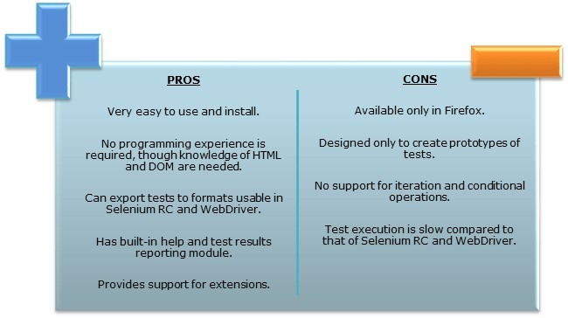

Brief Introduction Selenium Remote Control

Selenium RC was the flagship testing framework of the whole Selenium project for a long time. This is the first automated web testing tool that allowed users to use a programming language they prefer. As of version 2.25.0, RC can support the following programming languages.

\*Java

\* C#

\*PHP

\* Python

\* Per

\* Ruby

l

Brief Introduction Web Driver

The WebDriver proves itself to be better than both Selenium IDE and Selenium RC in many aspects. It implements a more modern and stable approach in automating the browser’s actions. WebDriver , unlike Selenium RC, does not rely on JavaScript for Selenium Automation Testing. It controls the browser by directly communicating with it.

The supported languages are the same as those in Selenium RC.

\*java

\*C#

\*PHP

\*Python

\*Perl

\*Ruby

Selenium Grid

Selenium Grid is a tool used together with selenium RC to run parallel tests

Features:

Enables simultaneous running of tests in multiple browsers and environments.

Saves time enormously.

Utilizes the hub-and-nodes concept. The hub acts as a central source of Selenium commands to each node connected to it.